1. 
2. 
3. 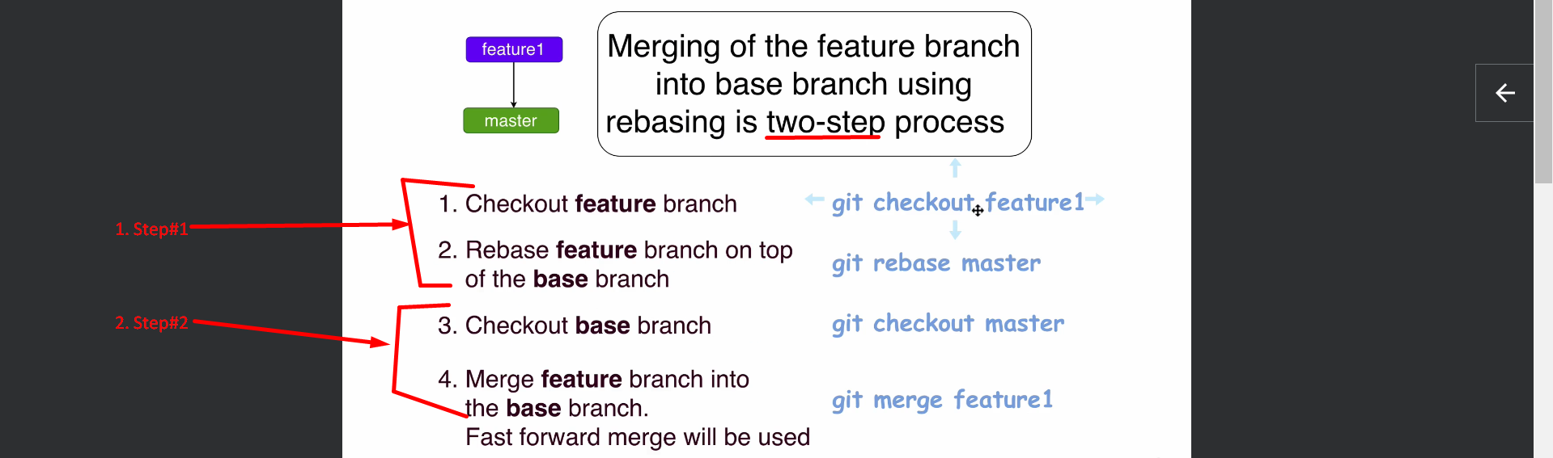
4. 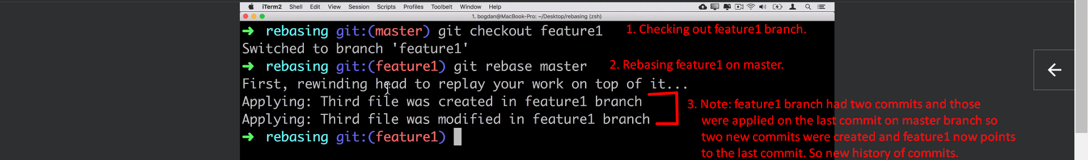
5. 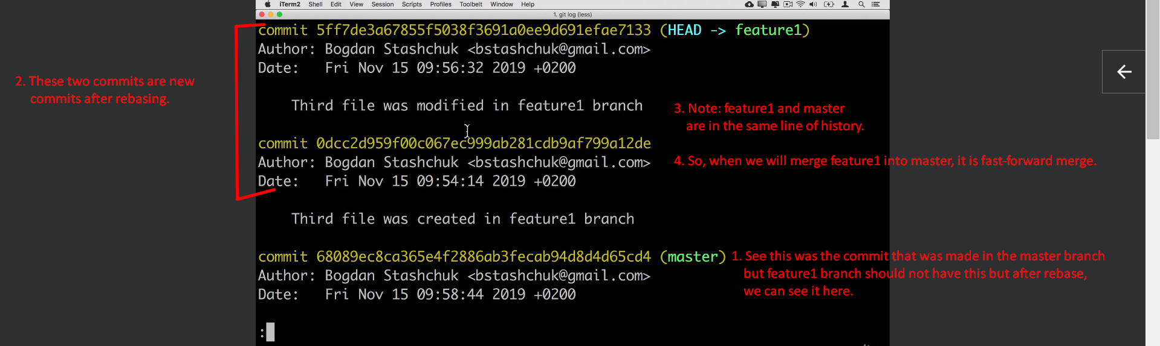
6. 
7. Let us follow the 2nd step for rebasing in next lecture.